
FAA PMA/STC
QUALITY MANUAL
(PQM)
Document No.:
PQM-422-1
Revision H

Contents
Scope 2
Responsibilities 3
Definition of Terms 3
Quality System Requirements 3
1.1 Introduction 3
1.1.1 14 CFR §21.308 Quality manual 5
1.1.2 14 CFR §21.310 Inspections and tests 5
1.1.3 14 CFR §21.320 Changes in quality system 6
1.1.4 14 CFR §21.305 Organization 6
1.1.5 14 CFR §21.309 Location of/or change to manufacturing facilities 6
1.1.6 14 CFR §21.310 Inspection and test 7
1.1.7 14 CFR §21.316 Responsibility of Holder 7
1.1.8 14 CFR §21.319 Design changes 8
1.1.9 14 CFR §21.320 Changes in quality system. 8
1.1.10 14 CFR §21.3 Reporting of failures, malfunctions, and defects 9
1.2 Quality System Regulatory Compliance 9
1.3 Manual Revisions 9
1.4 Marking requirements for PMA articles, Life limited and Critical parts 10
1.4.1 14 CFR §45.15 Marking requirements for PMA articles and Critical parts 10
1.4.2 14 CFR §45.16 Marking of life-limited parts 10
1.5 14 CFR 21, Subpart G, “Production Certificates”, sections §21.137(a) thru 21.137(o) 11
1.5.1 Burrana uses the approved SPR-F-750-08 PQPDL (Production Quality Procedure Document List) to capture all requirements in documentation and their current approved revisions. 11
1.5.2 As required by 14 CFR Part 21 as of this writing, Burrana’s approved quality management system includes documentation that covers the following 15 items and captures them in the PQPDL: 11
References 12
Record of Revisions 12
Appendix 1 A-530-02 13
Appendix 2 FAA Approved PMA/STC Quality Document List 14

Scope

This FAA PMA/STC Quality Manual is an introduction and guide through the Quality System requirements for Burrana for the manufacturing of articles as a Production Approval Holder (PAH).
As a result of Burrana’s need to hold Parts Manufacturing Approvals (PMAs) and to be granted production approval holder status from the Federal Aviation Administration (FAA), this document was written to fulfill the requirements for a Quality Manual.
Burrana Locations
Main location - 743 W Spring Creek Pl Suite 100 (Suite 500, Springville, UT 84663
Satellite location for inspection of PMA articles – UPS SCS building, 1757 Carr Road, Suite 100 E, Calexico, CA 92231.

Responsibilities

The Quality Manager is responsible for this manual. All Burrana employees are responsible to adhere to the requirements outlined in this manual.

Definition of Terms

TERM | MEANING
14 CFR | Code of Federal Regulations for Civil Aviation (USA)
CLOA | Certificate and Letter of Authority
COS | Continuous Operational Safety
ESD | Electrostatic Discharge
FAA | Federal Aviation Administration
FAIR | First Article Inspection Report
FOD | Foreign Object Damage
GQMS | Global Quality Management System
MIDO | Manufacturing Inspection District Office
PAH | Production Approval Holder
PMA | Parts Manufacturing Approval
PQM | Production Quality Manual – FAA PMA/STC Quality Manual
QMS | Quality Management System
QSM | Quality System Manual
SOP | Standard Operating Procedure
STC | Supplemental Type Certificate

Quality System Requirements

Introduction
The Burrana Global Quality Management System (GQMS) consists of central Quality System Manual (QSM) and associated Standard Operating Procedures (SOP). Diverse manuals, such as this FAA PMA/STC Quality Manual (PQM) have been created as a guide to show how our GQMS complies with applicable regulatory requirements of the FAA 21 CFR a-o (refer to Figure 4-1).
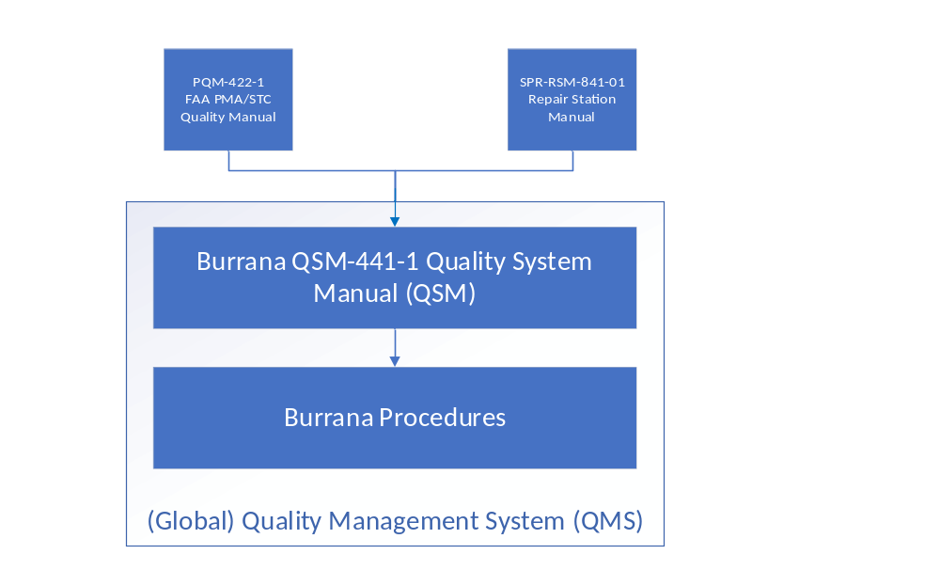Figure 4-1 – Global Quality Management System

14 CFR §21.308 Quality manual
(Primary responsibility: Quality Director)
As a result of the need for Burrana, Inc. (Burrana) to hold Parts Manufacturing Approvals (PMAs) and to be granted production approval holder status from the FAA. This document was written to fulfill the requirements for a Quality Manual as outlined in Title 14 of the Code of Federal Regulations (CFR) Part 21 (a.k.a., 14 CFR Part 21), in “Quality Manual” paragraph §21.308
The Burrana Quality Management System (QMS) as referenced in this manual addresses the specific quality manual requirements as detailed in 14 CFR part 21, §21.137. This manual and the Burrana QSM-441-1 Quality System Manual (QSM) describes Burrana’s quality system, it is written in the English language, it is retrievable in a form acceptable to the FAA, and it must be approved by the FAA before use. For the purposes of the FAA Phoenix Manufacturing Inspection District Office (MIDO), this quality manual applies to Burrana as a production approval holder for the manufacture of FAA approved articles and products.
This manual has been written to ensure the conformity of components and assemblies to Burrana FAA approved design data. The FAA Parts Manufacturing Approval programs are under the management of Burrana, with the Global Quality Assurance and Regulatory Compliance Manager acting as the FAA’s primary point of contract for this manual. The management recognizes it is fully responsible for the quality of its PMA products, regardless of whether manufactured in-house at Burrana or subcontracted to outside suppliers.
Note: Procedural changes to SOP’s and Work Instructions that may affect the inspection, conformity, or airworthiness of articles must be reported to the FAA.
Validation:
Burrana shall inform the FAA, in writing, of changes that may affect the inspection, conformity, or airworthiness, including all risk mitigation plans as well. Burrana will continue to review this procedure and all procedures annually to assure compliance. Annual reviews will be documented in the Quality Management Review.

14 CFR §21.310 Inspections and tests
(Primary responsibility: Quality)
In compliance with 14 CFR Part 21, paragraph §21.310, “Inspections and tests”, Burrana must allow the FAA to inspect its quality system, facilities, technical data, and any manufactured products or articles and witness any tests, including any inspections or tests at a supplier facility, necessary to determine compliance with the applicable FAA rule.
Validation:
Burrana has and shall continue to allow the FAA access to our facility and will pass this requirement to our suppliers. This requirement is passed to each and every supplier upon acceptance of our purchase order. Reference PUR-QSM-842-01 section 2.1- Supplier Quality Requirements PMA. This shall remain in place for all suppliers. Burrana will review this procedure annually for compliance.

14 CFR §21.320 Changes in quality system
(Primary responsibility: Quality)
In compliance with 14 CFR Part 21, paragraph §21.320, Burrana acknowledges that each change to the quality system is subject to review by the FAA. In addition, Burrana shall notify the FAA, in writing, Using the approved SPR-F-750-08 PQPDL immediately of any change that may affect the inspection, conformity, or airworthiness of its product or article.
Validation:
Quality will notify the FAA in writing within ten business days of any changes that affect inspection, conformity, or airworthiness of its product. Each procedure revision will be evaluated and documented for its impact on inspection, conformity, or airworthiness of Burrana products.

14 CFR §21.305 Organization
In compliance with 14 CFR Part 21.305, Burrana must provide the FAA with a document describing assigned responsibilities and delegated authority, and the functional relationship of those responsible for quality to management and other organizational components.
Validation: See QSM-441-1 Quality System Manual, §2.2 for Burrana organizational information.
Structural Org Chart Appendix 1

14 CFR §21.309 Location of/or change to manufacturing facilities
(Primary responsibility: Quality)
In compliance with 14 CFR Part 21, Paragraph §21.309(a) Burrana may obtain a PMA for manufacturing facilities located outside of the United States if the FAA finds no undue burden in administering the applicable requirements of Title 49 U.S.C. and this chapter.
Validation:
Quality shall notify the FAA, in writing, of any product that Burrana has made in a foreign country so that the FAA can decide if there is no undue burden prior to purchasing that product. Included in the notification will be a plan to mitigate any risk of the sourcing decision, so that the FAA can make a value decision.
In compliance with 14 CFR Part 21, Paragraph §21.309(b) Burrana shall obtain FAA approval before making any changes to the location of its manufacturing facilities.
Validation:
Burrana shall notify the FAA in writing of any change in location of the Burrana facility, prior to changes, to obtain FAA approval. Should a supplier change their location, this will be handled through Burrana’s Supplier Quality System and must include at a minimum a First Article Inspection Report (FAIR) validating all drawing requirements.
In compliance with 14 CFR Part 21, Paragraph §21.309(c) Burrana shall immediately notify the FAA, in writing, of any changes to the manufacturing facilities that may affect the inspection, conformity, or airworthiness of its PMA articles.
Validation:
Burrana shall notify the FAA in writing of any changes to the Burrana facility that may affect the inspection, conformity, or airworthiness of its PMA articles. Burrana shall document the impact and any mitigation plans. Should a supplier change their facilities, this will be handled through Burrana’s Supplier Quality System and must include at a minimum a FAIR validating all drawing requirements.
Current locations for inspection are as follows:
Main location - 743 W Spring Creek Pl Suite 100 (Suite 500, Springville, UT 84663
Satellite location for inspection of PMA articles – UPS SCS building, 1757 Carr Road, Suite 100 E, Calexico, CA 92231.
Any change to these locations or the processes maintained by them will be notified to the FAA MIDO office as required.

14 CFR §21.310 Inspection and test
(Primary responsibility: Engineering)
In compliance with 14 CFR Part 21, Paragraph §21.310(a).
In compliance with 14 CFR Part 21, Paragraph §21.310(b)(1) Unless otherwise authorized by the FAA, Burrana shall not present any article to the FAA for an inspection or test unless compliance with §21.303(b)(2) through (4) has been shown for that article.
In compliance with 14 CFR Part 21, Paragraph §21.310(b)(2) Burrana shall not make any change to an article between the time that compliance with §21.303(b)(2) through (4) is shown for that article and the time that the article is presented to the FAA for the inspection or test.

14 CFR §21.316 Responsibility of Holder
(Primary responsibility: Quality)
Burrana will/must:
(a) Amend this document as required by §21.305 as necessary to reflect changes in the organization and provide these amendments to the FAA;
(b) Maintain the quality system in compliance with the data and procedures approved for the PMA;
(c) Ensure that each PMA article conforms to its approved design and is in a condition for safe operation;
(d) Mark the PMA article for which an approval has been issued. Marking must be in accordance with part 45 of this chapter, including any critical parts;
(e) Identify any portion of the PMA article ( e.g., sub-assemblies, component parts, or replacement articles) that leave the manufacturer's facility as FAA approved with the manufacturer's part number and name, trademark, symbol, or other FAA approved manufacturer's identification;
(f) Have access to design data necessary to determine conformity and airworthiness for each article produced under the PMA;
(g) Retain each document granting PMA and make it available to the FAA upon request; and
(h) Burrana does not delegate authority to its suppliers, however, should we decide to do this, Burrana will make available to the FAA information regarding all delegation of authority to suppliers.
Validation:
Burrana will perform an annual review for these requirements and assure that each procedure revision still complies with these requirements.

14 CFR §21.319 Design changes
(Primary responsibility: Engineering)
(a) Classification of design changes.
(1) A “minor change” to the design of an article produced under a PMA is one that has no appreciable effect on the approval basis.
(2) A “major change” to the design of an article produced under a PMA is any change that is not minor.
(b) Approval of design changes.
(1) Minor changes to the basic design of a PMA may be approved using a method acceptable to the FAA.
(2) The PMA holder must obtain FAA approval of any major change before including it in the design of an article produced under a PMA.
Validation:
Burrana procedure only allows minor changes by Burrana. Burrana will not establish any procedure that allows the approval of major changes without FAA approval. This will be validated at each procedure revision and during annual review.

14 CFR §21.320 Changes in quality system.
(Primary responsibility: Quality)
After the issuance of a PMA Burrana will assure that:
(a) Each change to the quality system is subject to review by the FAA; and
Validation:
Burrana will give the FAA unfettered access to Burrana procedures at any time.
(b) Burrana must immediately notify the FAA, in writing, of any change that may affect the inspection, conformity, or airworthiness of its article.
Validation: (see section 4.1 of this document)

14 CFR §21.3 Reporting of failures, malfunctions, and defects
Burrana will report to the regulatory authorities any failure, malfunction, or defect in any product or article it manufactures that has left its quality system resulted or may result in any of the occurrences listed in 14 CFR §21.3 (c).
Validation: (see the Burrana Continuous Operational Safety (COS) procedures in QC-P-870-02 COS Response Team)

Quality System Regulatory Compliance

This Burrana quality system reflects the requirements of 14 CFR Part 21 and its associated 14 CFR Parts.
These include the following:
- Applicable Parts of Title 14 of the Code of Federal Regulations (CFRs)
- Part 1 Definitions and Abbreviations
- Part 21 Certification Procedures for Products and Parts
- Part 43 Maintenance, Preventive Maintenance, Rebuilding, and Alteration
- Part 45 Identification and Registration Marking
Specifically, Burrana’s quality system, as noted in this PQM, is organized to meet the requirements of 14 CFR Part 21 Subpart G, §21.137 “Quality system”, which is the quality system requirement for both 14 CFR Part 21 Subpart K §21.307 “Quality System”
The requirements, recommendations and best practices of the documents listed in the reference section of this document were key inputs into the construction of Burrana’s quality assurance program and this manual.

Manual Revisions

This manual and the Burrana QSM shall be revised as necessary to ensure the current requirements are addressed, and that current procedures are being followed in Burrana’s quality system. All proposed manual revisions will be submitted to the Phoenix MIDO, which is responsible for the production certificate oversight of Burrana.
Applicable comments resulting from the FAA’s review shall be incorporated and an updated version of the document shall then be resubmitted to the MIDO for review. The proposed revision will not be released for use to the Burrana quality system until written documentation approving the revision has been received from the FAA MIDO.
Proposed updates will be submitted when considered necessary and will be submitted on an “as needed” basis, however, this document will be reviewed annually to assure compliance and that it remains current. Whenever revisions to this manual and the Burrana QSM are necessary, the new revision will be identified by a revision letter (e.g. A, B, C, etc.) and a revision date.

Marking requirements for PMA articles, Life limited and Critical parts
(Primary responsibility: Engineering)

14 CFR §45.15 Marking requirements for PMA articles and Critical parts
(a) PMA articles: The Burrana must permanently and legibly mark:
(1) Each PMA article, with the PMA holder's name, trademark, symbol, or other FAA approved identification and part number; and
(2) The letters “FAA-PMA”.
(b) TSO articles – Not applicable to Burrana
(c) For Burrana to manufacture a critical part, Burrana must permanently and legibly mark that part with a serial number (or equivalent) unique to that part in addition to meeting the other applicable requirements of 14 CFR 45.
(d) If the FAA finds a part or article is too small or otherwise impractical to mark with any of the information required by this part, the manufacturer must attach that information to the part or its container.

14 CFR §45.16 Marking of life-limited parts
Burrana does not make any parts that are defined as life limited parts at this time, so the marking requirements for life limited parts are currently not applicable.
Should Burrana manufacture a life limited part, Burrana must comply with §43.10 of 14 CFR Part 45, and must provide marking instructions, or must state that the part cannot be practicably marked without compromising its integrity.
Quality Manual Requirements

14 CFR 21, Subpart G, “Production Certificates”, sections §21.137(a) thru 21.137(o)

Burrana uses the approved SPR-F-750-08 PQPDL (Production Quality Procedure Document List) to capture all requirements in documentation and their current approved revisions.

As required by 14 CFR Part 21 as of this writing, Burrana’s approved quality management system includes documentation that covers the following 15 items and captures them in the PQPDL:
- Design data control, as noted in §21.137(a);
- Document control, as noted in §21.137(b);
- Supplier control, as noted in §21.137(c);
- Manufacturing process control, as noted in §21.137(d);
- Inspecting and testing, as noted in §21.137(e);
- Inspection, measuring, and test equipment control, as noted in §21.137(f);
- Inspection and test status, as noted in §21.137(g);
Note:
This requirement does not include 8130-3 activities considered to be maintenance activities allowed to be performed by a manufacturer, such as rebuild or alteration functions. Refer to FAA Order 8130.21 for examples and guidance regarding the use of FAA 8130-3 forms by a PAH for approval to return to service after rebuilding, altering, or inspecting. Internal requirements indicate that a person must be authorized by Burrana specifically to complete 8130-3s for this type of activity.

- Nonconforming product and article control, as noted in §21.137(h),
- Corrective and preventive actions, as noted in §21.137(i);
- Handling and storage, as noted in §21.137(j);
- Control of quality records, as noted in §21.137(k);
- Internal audits, as noted in §21.137(l);
- In-service feedback, as noted in §21.137(m); and
- Quality escapes, as noted in §21.137(n).
- Issueing authorized release document, as noted in §21.137(o).

References
FAA General
FAA Regulatory and Guidance Library (RGL) | This can be found at found at http://rgl.faa.gov/
Federal Register  Final Rules: 14 CFR Parts 1, 21, 43, and 45, dated August 13, 2015 | This can be found at: http://www.ecfr.gov/cgi-bin/text-idx?SID=b5de95e2ddcf33211a673dfdae822be3&mc=true&tpl=/ecfrbrowse/Title14/14cfrv1_02.tpl#0
PS-AIR-21-1901 | Use of Remote Technology During the Performance of Inspections and Tests
AC-00-68 | Aircraft Certification Service Voluntary Disclosure Reporting Program
14 CFR 21.137 | Quality System
FAA PS-AIR-21-1901 | Use of Remote Technology During the Performance of Inspections and Tests
AC 00-68 FAA Order for Self-Disclosure | https://www.faa.gov/documentLibrary/media/Advisory_Circular/AC_00-68.pdf
FAA Orders

Order 8120.22 | Production Approval Procedures
Order 8120.23 | Certificate Management of Production Approval Holders
Order 8130.21 | Procedures for Completion and use of the Authorized Release Certificate, FAA Form 8130-3, Airworthiness Approval Tag
Order 8110.42 | Parts Manufacturer Approval Procedures

Record of Revisions

Rev. | Description of Change | Approver | Eff. Date
D | Company name changed to Burrana, Inc. – all pages | M. Craig Leftwich | 02-MAY-2019
E | Update to reflect new Org chart, updated for remote inspection, updated to remove references to non-related documents (TSSO), added reference to AC-00-68 for self-disclosure, Table 5.1, Removed “0” from document number where incorrect and updated “COA” to CLOA”  Added in section 5.1.15 to include requirements of 21.317 (o)  Corrected 21.416 to 21.316  Removed 21.138 from 4.1.1  Corrected 21.150 to 21.320  Removed 21.140 from 4.1.2 | Brian R. Olea | 28 May 2020
F | Added Appendix 2 PQPDL  5.1.15 Updated for remote inspections  5.1.7 added Reference to (o) and removed requirement for FAA appointed inspections  Removed “must have” and replaced with “maintains”  Included SPR-P-852-11 Authorized Representative in (o)  Updated Table of Contents | Brian R. Olea | 1 Jul 2020

Appendix 1 A-530-02

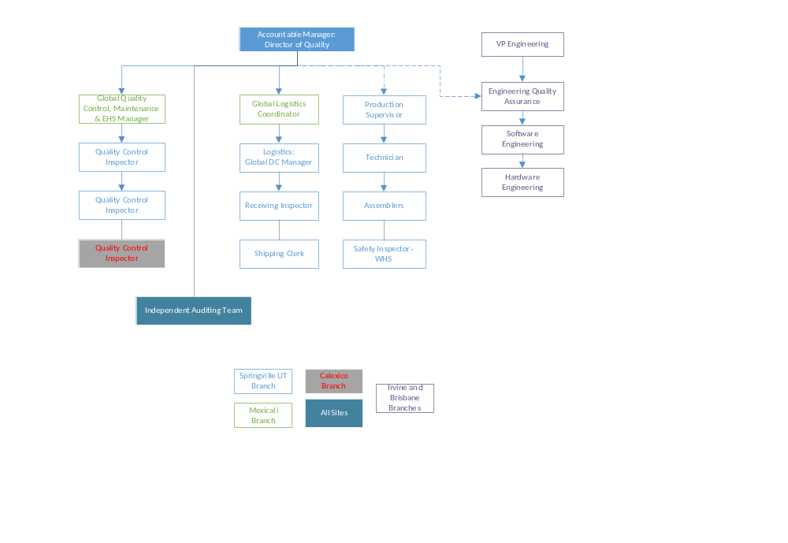

Appendix 2 FAA Approved PMA/STC Quality Document List
This list is documented on SPR-F-750-08 Production Quality Procedure Document List (PQPDL) and approved by the FAA MIDO when changes are required. PQPDL will list the latest revision of the document and will be used as approval for document changes when they are submitted for approval.

